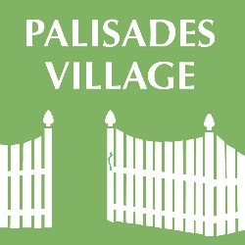
Palisades Village Update on Events and Activities
April 6, 2020

This year many are observing their religious services and holidays very differently than in the past. And even though there is sadness and disappointment in not continuing many of our traditional celebrations, thanks to Zoom and other virtual platforms, we are adjusting to new ways of communicating. My family and friends are really enjoying being "together". Why didn't we establish these weekly traditions before? I think at the end of this, we'll have to restock our wine cellar! We've hosted so many happy hours!
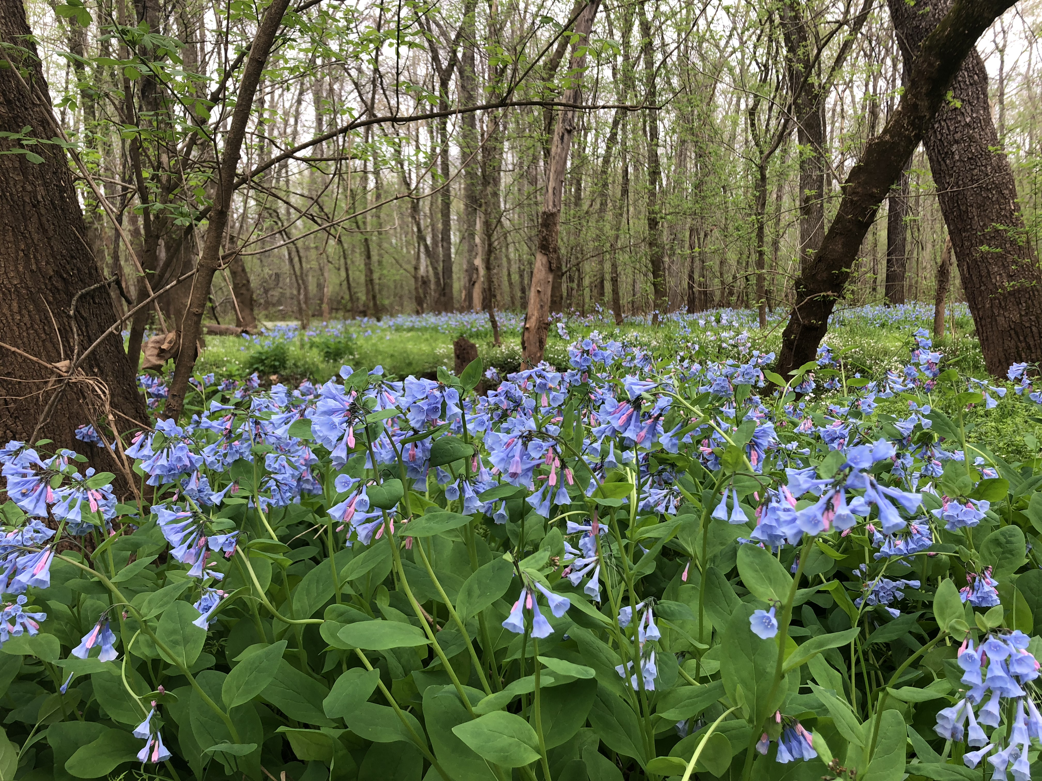

We are so fortunate that springtime is here and we have such pleasant weather. I am mesmerized by the beauty of nature's bounty and the brilliant colors: the tulips, azalea bushes, redbuds, cherry trees, dogwoods and lilacs are all in bloom. One of last year's weekend delights was going to Merrimac Farms Wildlife Management Area in Nokesville, Va. for its annual Bluebell Festival. I meandered in the beauty of the forest and the bluebells that carpeted the Cedar Run waterway for miles. I relished in the acres of clusters of perennial bell-shaped flowers so much that I repeated my hike along the dirt paved path. The festival was supposed to take place this Saturday. Luckily, I saved a few photos and can still savor their beauty. I hope you will too.
---Andrea Saccoccia, Executive Director

Events Update:

Having problems hearing on the phone? Palisades Village invites you and your neighbors to a special presentation sponsored by DC Relay and Captioned Telephones on Tuesday, April 7 at 11 a.m. These phones allow you to "see what they say". This is a program of the Public Service Commission of the District of Columbia. DC Relay provides a 24-hour communication service that connects people who are deaf, hard of hearing, deaf-blind or have difficulty speaking that may use specialized telephone equipment to people who use standard telephones. There is no cost to use DC Relay, although equipment and long-distance charges may apply.

Hamilton Relay also offers DC Captioned Telecommunications Relay Service (DC CapTel) to District residents who use CapTel phones. CapTel phones allow users to receive word-for-word captions of their telephone conversations. The captions are displayed on their phones built-in screens so users can read the words while listening to the voice of the other party. Captioned telephone calls can also be made on internet-connected computers, smartphones or tablets.

Please join the Village as we learn about all of the options available. You can register at https://register.gotowebinar.com/register/4934002760524799756. You will need to enter your name, email and indicate whether if you require accommodations in the form of ASL interpretation, CART or not, in order to participate in the webinar.

Please note there will be no yoga this Tuesday but class will go on as scheduled for Thursday, April 8 at 2 p.m.

We have some disappointing news to share with you:

The Palisades Village Eighth Annual House Tour scheduled for October 19, 2020, has been canceled by the Board of Directors. Continuing to plan the House Tour in the uncertainty of Covid-19 and how it will impact the health of our community in the summer and fall months would make it extremely difficult to move forward. Most importantly, we are very concerned about promoting and encouraging an event where our most at-risk community members may be exposed to the virus. Palisades Village has been working on new ways to support our members and the broader community in these challenging times.

As you can imagine this is a huge blow to Palisades Village’s current budget. This is one of the organization’s major fundraisers, accounting for about 17% of our annual budget. The House Tour Committee will be exploring ideas including online “events” for 2020 to strengthen our community and raise funds to mitigate the loss of our House Tour revenue. If you are interested in brainstorming about what might make sense as appropriate substitute events, please let the House Tour Co-chairs, Carol Lynn Halal, clhalal@gmail.com and/or John Stiner, jstiner@breckdesign.com, know. Meanwhile, take care and stay well!

Creative Corner:

This is CONTEMPLATING CHAOS, 40 high by 57 inches wide.

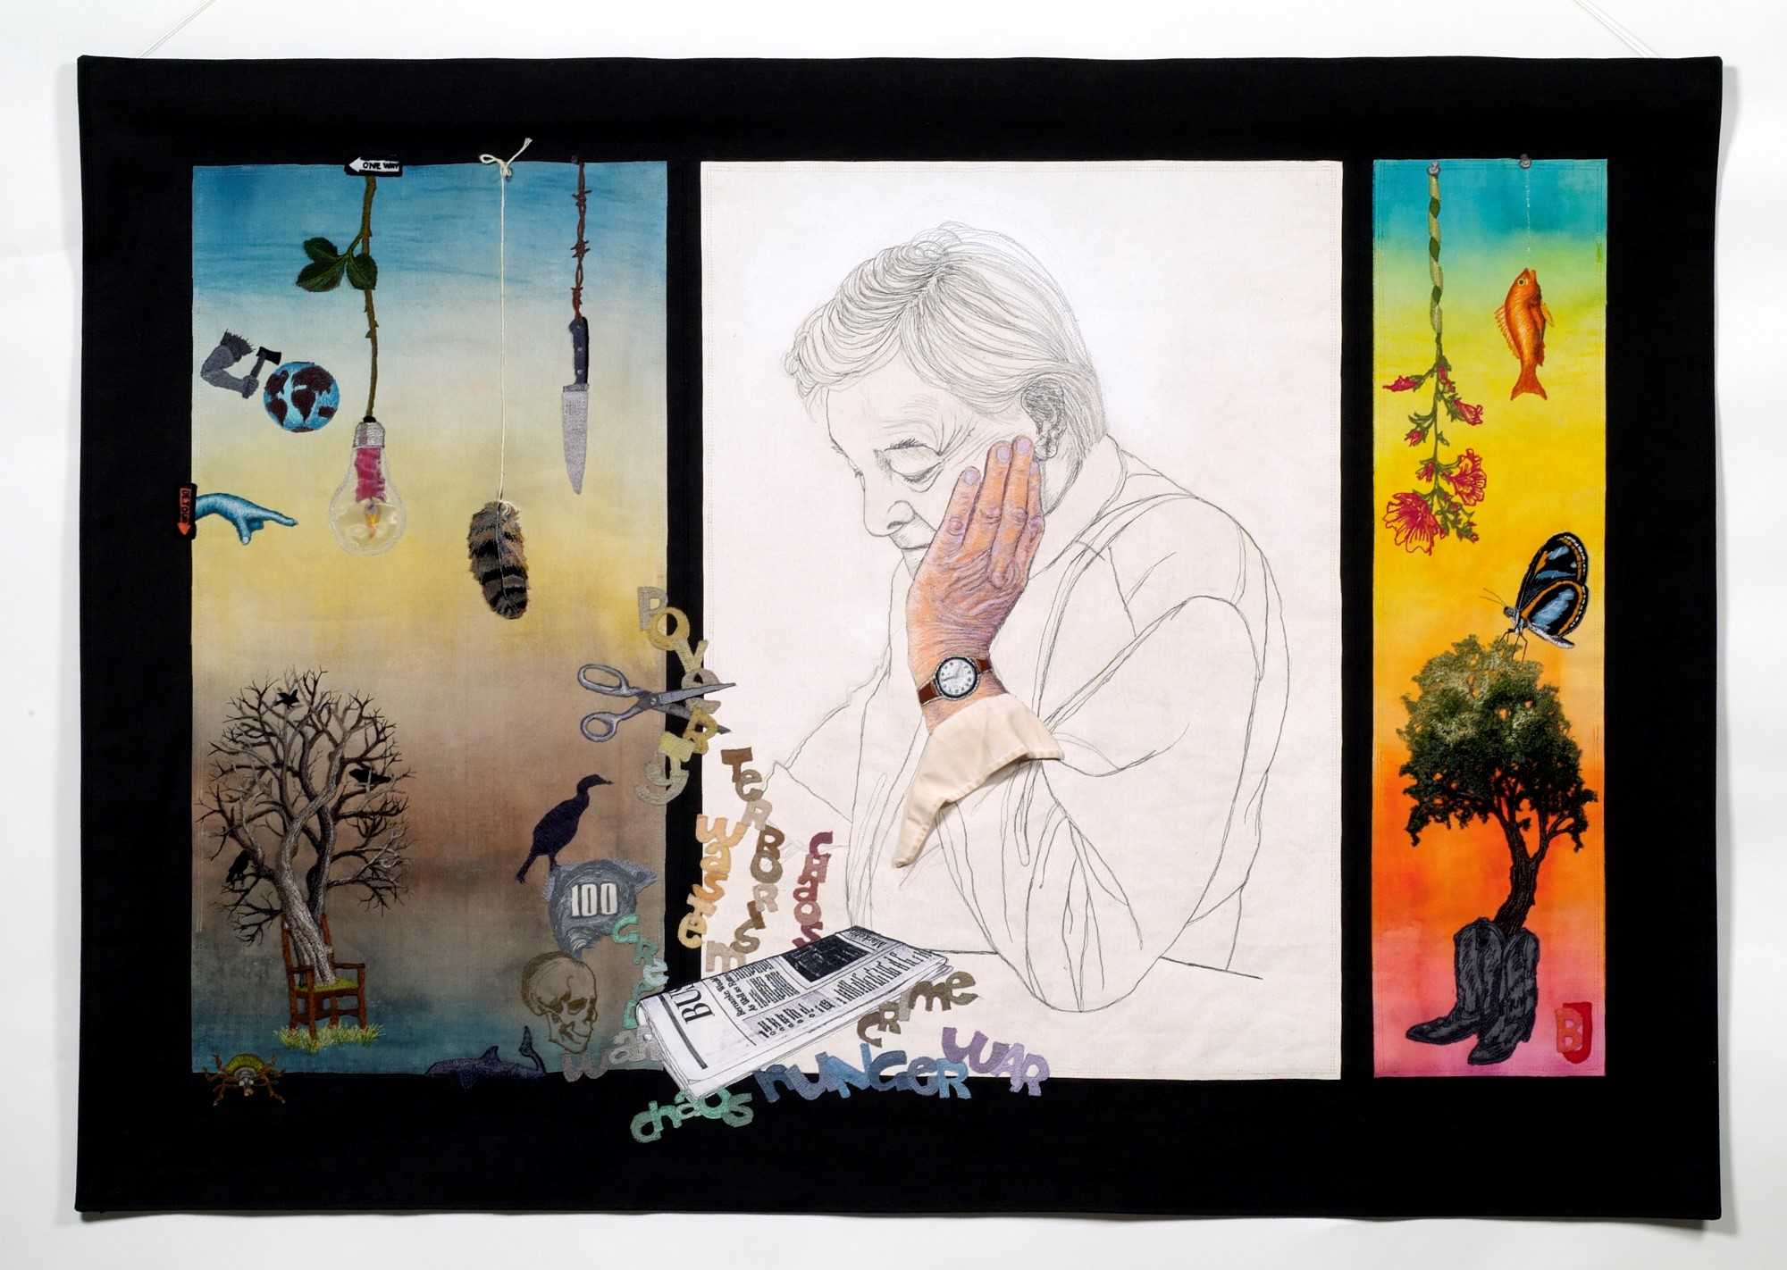

This statement was included with it in an exhibit in Philadelphia in 2006…..

"There has been Chaos in the financial world for quite a while, now ……Notice the Business section of the Washington POST newspaper in the center section. But, there can be positive chaos as well as negative chaos. This, then, is an allegory expressed by a multi-layered surrealistic view of CHAOS."
I would change that statement for today’s history/news leaving out the financial world, although that is also relevant, but health, safety and people are more important, now?

About this artwork:
There are three sections, the left section represent negative chaos and the far right section is to represent positive chaos, both abstracted with various images. The center section shows my husband, Clark as he reads the paper. The words if you cannot read them: POVERTY, TERRORISM, WASTE, CHAOS, CRIME, WAR, AND HUNGER. Now I would have added Pandemic or disease.
Most all of my work is embroidery appliquéd on softly painted canvas. I wanted a pencil sketch of Clark so used a gray thread to look like pencil lead.. That is a real cuff from one of his shirts and all the other images are free-machine embroidery, completely created with thread. I create each small image on the machine and then add it to the background. I did the pencil like drawing of Clark right on the canvas background.
Artist: BJ Adams, Palisades Village member

From the YMCA:

Here is a Fish Out of Water workout from the aquatics instructor that doesn't require water.

Need someone to chat with on the phone?

Palisades Village received a request from Dr. Louisa Whiteside, George Washington University Geriatrics Program, seeking to connect Geriatrics fellows with seniors who are presently living alone or feeling isolated. This is an opportunity to talk with students about how this crisis is impacting our lives. Your participation will result in a great inter-generational friendship!

If you would like to participate and receive a phone call, please email the fellows with your name and telephone number to gwureachingout@gmail.com, submit your information via the website at gwureachingout.com, or call 202-709-6344 and leave a voice message with your name, phone number, and preferred call time. A student will follow up with you in the coming weeks.

Want to make a face mask without sewing?

Here is a video of the Surgeon General making a mask -- no sewing required:

https://www.wafb.com/2020/04/04/surgeon-general-releases-video-demonstrating-how-make-face-masks/

The hard part is not finding an excuse to pull it down or off. It does not function if it is not covering your nose and mouth. The Centers for Disease Control and Prevention are recommending the voluntary use of face coverings when in public.

Iona's Emergency Food Pantry
Iona Senior Services is urgently trying to keep the emergency COVID-19 Food Pantry Plus stocked with shelf-stable food and home supplies. In these unprecedented times, Iona is working hard to meet the needs of our most vulnerable clients who simply cannot go out to buy food or other necessary items. While many are receiving home-delivered meals provided by the Department of Aging and Community Living, most still need additional food to supplement the once-a-day frozen meal. And we are already getting many requests for toilet paper, paper towels, disinfecting wipes, trash bags, and the like.
Here is a complete list of what our older neighbors desperately need:
Food and Drinks:
- Canned or packet tuna, chicken, or salmon
- Hormel Compleats shelf stable meals, any kind
- Barilla shelf stable pasta meals, any kind
- Canned soups - especially those with chicken and beef but also vegetable soups
- Cup soup products, especially those with vegetables or beans and reduced sodium
- Canned fruit, juice sweetened - peaches, pears, mixed fruits, mandarin oranges are big favorites
- Canned vegetables, reduced sodium appreciated
- Fruit cups, juice sweetened
- Dried fruits - prunes, apricots, cranberries
- Snack pack puddings - shelf stable
- Baked beans and other canned beans/legumes
- Macaroni and Cheese - box or instant "add water" cups
- Shelf stable milk unflavored
- Smooth peanut butter
- Jelly or jam
- Granola, fruit & grain, or protein bars, preferably softer
- Cookies any kind
- Crackers - any kind of crackers, preferably softer butter or "Club-type" crackers, or whole grain
- Juice boxes any kind of fruit juice boxes, 100% fruit juice preferred
Cleaning/Home Supplies:
- Bleach, smaller bottles preferred
- Bleach spray or other cleaners
- Toilet cleaner
- Rubber gloves - like for doing dishes
- Dishwashing liquid, like Dawn, etc.
- Sponges
- Laundry detergent - any kind, pods or bottles
- Tall kitchen trash bags
- Paper towels
- Toilet paper
- Disposable gloves
Hygiene Supplies:
- Razors
- Bar soap
- Body wash
- Body lotion
- Toothpaste and brushes
- Deodorant
- Incontinence products - adult pull up diapers, preferably medium and large
If you can safely do some shopping, or have some unopened extras in your own pantries and closets you can spare (please check expiration date), please bag or box them up and bring them to Iona on Saturday, April 11 from 10 a.m.-12 noon. No need to call ahead; just come to our back circle and we will have staff ready to safely receive the items. One or two cars at a time can keep safe social distance and unload donations onto carts. Iona staff will move the materials into the building. (If you don’t know our back circle, you enter it by turning onto Murdock Mill Road, off of River Road, between the church and the exit for the Container Store/Target parking garage.)
Palisades Village member and volunteer, Janice is collecting for IONA. You can drop your donations on her front porch in the area that she has designated by 5 p.m. on April 10. Please- NO Expired products. 4921 Sherier Place - please put your donations on the front porch, not in the driveway or anywhere else. She will deliver them safely to Iona.

