Update on Palisades Village Events and Activities
April 16, 2020
Covid-19 has had a tremendous impact on our lives and each day we try to manage as best we can. Together we are stronger! We want you to know that Palisades Village is here to help. Are you concerned about going out to buy groceries or picking up your medication? Do you want to have someone deliver your items to your door? Many new neighborhood volunteers have been reaching out and asking to help our Village community. We understand the challenges you are facing and want to offer all of our members, regardless of your full or associate membership status, assistance as we are able. Please feel free to call the office at 202-244-3310 or e-mail eblanton@palisadesvillage.org and we'll work on coordinating your requests with a friendly volunteer. We're all in this together!
Today is Emancipation Day in the District. On this day in 1862, Abraham Lincoln signed the Compensated Emancipation Act which ended slavery for over 3,000 in the District, reimbursed those who had legally owned them and offered the newly freed women and men money to emigrate.
Wanderlust setting in? Our storytellers shared their travel stories on Tuesday and realized that there are so many more. They are going to continue on Tuesday, April 28 at 3 p.m. Bring a story about one of your travels, pour a cup of coffee or tea and join them. To register and get Zoom details go to https://palisades.helpfulvillage.com/events/388-storytelling.
Marti Bailey of Sibley Seniors is going to share her travel experiences and photos of Antarctica and South Georgia Island tomorrow, Friday, April 17 at 3:30 p.m. Register now. Do you have a travelogue that you want to share with other Palasadians? Let us know. We plan to feature your travels in the coming weeks.
Even though we are grounded for the moment, we can armchair travel! This lovely idea was suggested by Jill Dombrowski. Where would you like to travel next? Submit a destination suggestion along with a good link to capture your journey!
Fasten your seat belts, secure your belongs and don’t put your chairs in an upright and uncomfortable position!
First stop on your armchair travel is Poland!
https://youtu.be/BM-CB-ND9d4
Other Events this Week:
Roseanna is offering a new Mindful Knitting group tomorrow, Friday, March 17 at 11 a.m. Want to start or remember how to knit? Roseanna is there to help before the meetup. Email her at rschwamm@yahoo.com to set up a time. Weekly Roseanna offers meditation to jumpstart your day. Take 15-20 minutes in the morning to refresh and refocus. It's uplifting and very relaxing.
And to end the week on a fun note, join us for Happy Hour on Fridays at 5:30. Go to the website to let us know that you are coming and get the Zoom details.
Volunteers:
Does anyone have experience with laser printers for home use? A member wants to buy one and could use some advice. Contact Erica at eblanton@palisadesvillage.org if you can help out.
Do you need a mask? A volunteer is making some to help out our Village members and comply with the Mayor's orders that all wear masks when shopping. Let us know if need a mask or have some extra to share with our members.
The Palisades Farmers Market needs volunteers. Under the new rules they have to control the entrance and exit to the market, and so we need 8 volunteers to work 1 hour shifts at this Sunday's market. One hour shifts begin at 9:00, 10:00, 11:00 & 12:00. If you can help out, please email Barb Power and let me know which shifts you can do - whether a specific slot or any available - and she will be back in touch.
Book lovers:
Read everything in the house and itching for a new book? Kathy Sreedhar suggested a book exchange and has lots of mysteries to share. Would you be interested? Let us know and we can put you together with other book lovers.
For Sound of Music Fans!
Musical COVID-19 humor - The Sound of Music, Do Re Me
https://youtu.be/MMBh-eo3tvE
Creative Corner:
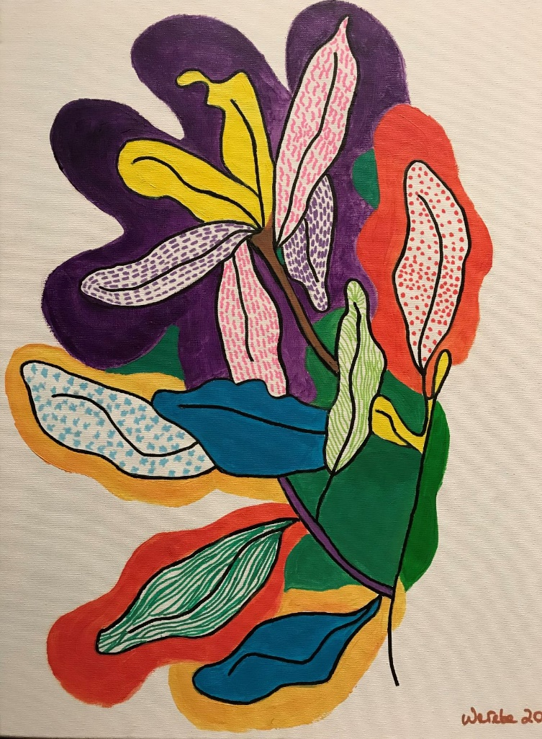
"These flowers are part of a series of paintings I'm working on called "Natureza" or Nature in Portuguese. I'm drawn to their colors and to nature's appeasing quality in these uncertain times. Painting helps me focus on joyful and inspirational subjects and color and form add to my sense of wellbeing. Through these, I hope to bring a bit of joy and optimism to others too. " Artist: Roberto Werebe
Movies:
"The Times of Bill Cunningham" is getting great reviews from members. You can watch films that were to be shown at the Avalon Theatre from your own home. "The Times of Bill Cunningham" receives three stars from the Washington Post. Told in Bill Cunningham's own words from a recently unearthed six-hour 1994 interview, the iconic street photographer and fashion historian chronicles, in his customarily cheerful and plainspoken manner, moonlighting as a milliner in France during the Korean War, his unique relationship with First Lady Jackie Kennedy, his four decades at The New York Times and his democratic view of fashion and society. Narrated by Sarah Jessica Parker, The Times of Bill Cunningham features incredible photographs chosen from over 3 million previously unpublicized images and documents from Cunningham. "This well-researched dive into mid-century social history treats viewers to a cornucopia of delicious photographs to accompany Cunningham's narration, plunging us into a world that feels both immediate and heartbreakingly gone forever." -Ann Hornaday, The Washington Post
From renowned British director Ken Loach "Sorry We Missed You" continues along with "Saint Frances" and "Fantastic Fungi"."The Booksellers" will be available on April 17.
Instructions for accessing each of these films appear on their website: https://www.theavalon.org. Avalon staff will monitor the email account from 10 a.m.-9 p.m. daily should you have questions. They will do their best to help and respond as quickly as possible, but please be aware that a close reading of the instructions which vary with each film may save you the effort of contacting them. $12 donation.
Taxes:
IRS creates web portal for payments to non-filers
If you didn’t file a tax return in 2018 or 2019, you were facing a difficult process to get the Economic Impact Payments that were set up by the federal government to help people facing hardship from the health crisis. Until now.
The IRS announced on Friday that they were setting up a web portal for people to put the necessary information online to get electronic payments.
You’ll need to give your full name, your current mailing address, your birth date, your Social Security number, your bank account and routing number (if you have one), your driver’s license or other government-issued ID (again, if you have one), your Identity Protection Personal Identification Number, if you were given one; and the names and Social Security numbers of any children you have.
You can find the page with more information on the IRS website. Scroll down a bit and click on the blue button that reads “Non-Filers: Enter Payment Info Here” to get started. Source: WTOP

Scam Alert: Do not give out any information to anyone who calls you about payments. The IRS will not call you but you can call them.

