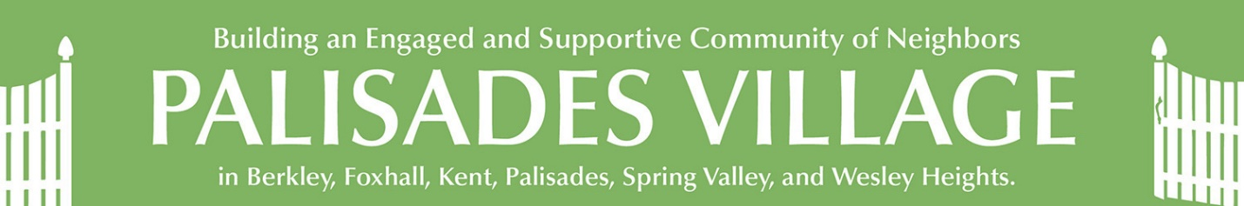
ACROSS THE FENCE
August 22, 2021
This Week at Palisades Village:

Monday, August 23 | Tuesday, August 24 | Wednesday, August 25 | Thursday, August 26 | Friday, August 27 | Saturday, August 28
3:30 p.m.  Fitness with William Yates  (offered in-person and via Zoom) | 3:00 p.m.  Storytelling | 8:30 a.m.  Walk with Wally | 3-6 p.m.  Community Happening

This week:
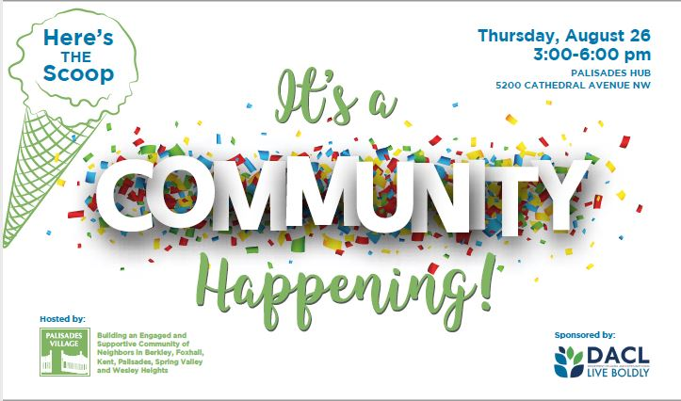
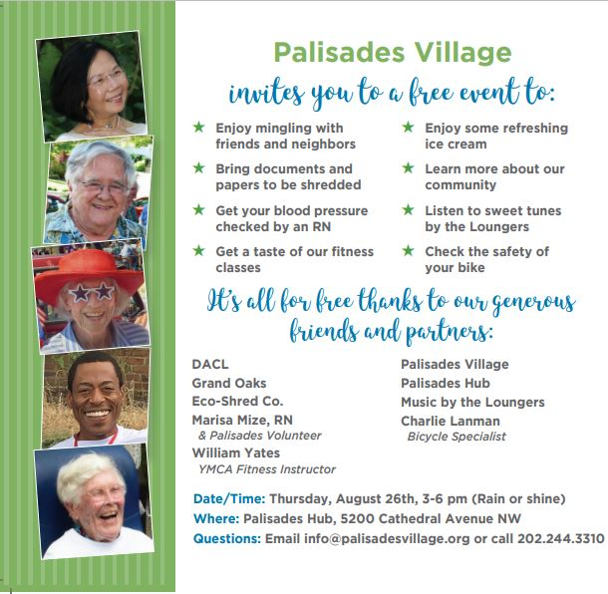

We still need a couple of Volunteers! You can sign up here or contact the office to help us make this event a huge success.
Coming up:

The next meeting of the Palisades Village Board of Directors will be held on Zoom on Thursday, September 2 at 5 p.m. The Board meeting is open to the public and visitors may comment and/or ask questions, but only Palisades Village Board members may vote.

The office will be closed on Monday, September 6 in observance of Labor Day. If possible, please submit any requests in advance.
Please register for all Palisades Village events that are held in-person or on Zoom. Click on the title in red to be taken to the registration page and get more information. Click on the registration button and provide your information. You will receive an email with your confirmation soon after. For events on Zoom, this will include the link. There is a complete listing of all events for the next two weeks at the end of the newsletter, or you can go to the website. If you have questions or want to register in person, please call the office at 202-244-3310.

COVID Corner:
Palisades Village’s Emergency Contingency Task Force has continued to meet to carefully monitor the latest pandemic information and ensure the safety of our community. As of August 19, 2021, Palisades Village has revised our own office policies.

Palisades Village’s Policy Updates
Palisades Village invites all to participate in most of its in-person outdoor events and activities, regardless of vaccination status. Participants that are fully vaccinated (which means two doses of either the Moderna or Pfizer vaccine or one dose of the Johnson and Johnson vaccine and a period of at least two weeks has passed since the final shot) do not have to wear a mask or be socially distant at our outdoor gatherings. Non-vaccinated participants must wear a mask and maintain a social distance (honor code) at all outdoor and indoor gatherings. Please wear a mask correctly (i.e., covering both mouth and nose) for the protection of others.

Palisades Village continues to encourage clubs and groups to meet outdoors or meet virtually but we recognize that with heat and inclement weather it may be necessary to meet indoors. All are required to wear and mask and remain socially distant at events held indoors.
We will continue to offer virtual social, educational, and cultural events using Zoom to accommodate those who prefer to join us from home.
Palisades Village encourages partially or non-vaccinated people to seek vaccination opportunities at any of the District’s walk-up sites, area hospitals or vaccination providers.

Volunteer Services:
If you need a ride or help at home (gardening, technical support, small home repairs, errands run, etc.), we will continue to offer these services to the extent that volunteers and members receiving the services are fully vaccinated. Please remember that the Palisades Village Office asks for 3 business days- notice to accommodate your requests. Contactless services will still be available to all members, regardless of their vaccination status.

Office Reopening:
Palisades Village will continue to carefully monitor the progress being made in our area to combat the virus. The Office is open to visitors, Monday to Thursday from 10 a.m. to 2 p.m. by appointment. Up to three people, including staff, volunteers and Board members are welcome to use the Office at any time. We want to keep everyone who uses the building (which includes a preschool) as safe as possible.

Additional information:
These standards are subject to change at any time, based on guidance from the CDC, the DC Department of Health, and/or the experience of Palisades Village. We will continue to keep you updated. As always, your safety is of utmost importance to us, and Palisades Village welcomes your input and feedback.

Need masks or hand sanitizer? We have some available at the office and will make them available at all of our events.

Did you know that you can do Covid tests at home? You can find details at https://coronavirus.dc.gov/testyourself.

Booster Shots:
Eligibility and availability details are still being developed for who, when, and where one can get a booster shot. However, a number of members have been able to get a booster shot at CVS (https://www.cvs.com/immunizations/covid-19-vaccine). Safeway is reportedly using different criteria for who is eligible to receive a booster. We will keep you posted.

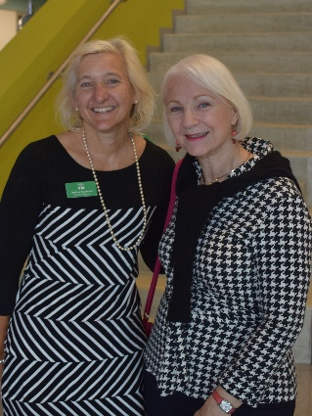
Fond farewells

Andrea Saccoccia and Carol Lynn Halal
We are all wishing Andrea the absolute best as she takes on new challenges. We are putting together a special album if you have a special note or photo that you would like to share with Andrea. Please send them to the office at PO Box 40403, Washington, DC 20016 or eblanton@palisadesvillage.org.

DC Village Collaboration
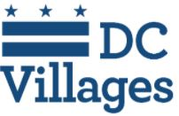
The DC Area Villages work closely together to share resources and access to many events.

For a list of all the events sponsored by Washington Area Villages, please click here. Here are just a few of them (and a couple that are not included). Register by clicking on the link in the title or in the description.

Tuesday, August 24, 3 - 4 p.m.
Contemporary Women Artists - 3 Who Pushed the Envelope -- Female artists make up a bit over 50% of acknowledged artists today, yet fewer than 5 to 6% of American museum holdings represent works by female artists. Explore three women whose works are or soon will be presented locally: Yayoi Kusama with "One with Eternity;" a follow-up to her blockbuster "Infinity Mirror Room at the Hirshhorn;" Lynda Benglis with her "pours" resembling paintings but sitting on the floor at the National Gallery of Art; and Emma Amos, former "Guerrilla Girl," with her bold colors, words, and fabrics creating figurative works in a major retrospective at the Philadelphia Museum of Art. Hosted by North Bethesda Village. Email park21217@aol.com by Aug. 22 to register.

Wednesday, August 25, 12:30-1:30 p.m.
African American Artists with Chichi Lovett: Session 5 -- Explore the work of well-known and lesser-known African American artists and their predecessors with Chichi Lovett. She uses works of art created by African American artists to examine assumptions to initiate and welcome conversations regarding issues concerning race, class, culture, the art market, and womanism/feminism (among other issues), that these pieces can instigate while learning to ‘read’ a piece from an artist’s perspective. We take time to look at this art and consider what it represents to you, the viewer, and why. Learn about the context of the art and artists in their own time and in ours. Art pieces discussed in this class will be different from those discussed in the previous classes that Chichi has offered during past sessions. Find more info and register here

Saturday, August 28, 2 - 3 p.m.
Corridor Conversation - Scattered Clouds: Finding Poetry in Washington, DC -- Join Reuben Jackson for a reading from his latest poetry collection, Scattered Clouds , and a discussion of how growing up in Washington, D.C., continues to influence his writing. Jackson curated the Smithsonian's Duke Ellington Collection and is an archivist at the UDC Felix E. Grant Jazz Archives, as well as co-host of WPFW's "The Sound of Surprise." His music reviews appear in numerous media outlets, and his poetry is widely anthologized. Corridor Conversations are organized by Hyattsville Aging in Place, Helping Hands University Park, Neighbors Helping Neighbors College Park, and Explorations on Aging with support from Maryland Milestones. Register in advance on this form.

Wednesday, September 8, 2:30 p.m.
Falls Prevention Classes Resume -- September is National Falls Prevention Awareness Month. According to the National Council on Aging, falls affect 1 in 4 Americans aged 65+ every year. Falls can be prevented through simple lifestyle adjustments, STRENGTH AND BALANCE EXERCISES, medication management, and regular vision checks.

Mark your calendar! Exercises supporting Falls Prevention resume on the second Wednesday of the month, starting September 8th from 2:30-3:30 p.m. via zoom. Thanks to Zoom, you can join this monthly series, led by an experienced physical therapist in the comfort of your home, and practice specific strength-building exercises that can help prevent falls. Regardless of your fitness level, if you have had a fall, or are afraid of falling, this series is for you. Have a chair nearby in a cleared space. Come to one or more of the sessions and see the results for yourself. Registration required. To register, click here.

The falls prevention classes from the Spring are still available to watch on YouTube here.

Wednesday, September 22, 12 noon
Coping with Incontinence -- Dr. Carter-Brooks will discuss incontinence and treatment options. Dr. Carter-Brooks is a urogynecologist at GW.

For those who might feel more comfortable, you can send Barbara questions in advance. She will ask the questions at the end of the presentation. Of course, attendees can also ask questions live if they prefer. To submit confidential questions or RSVP, please contact: Barbara Scott, Case Manager, casemanager@dupontcirclevillage.net Phone: 202-441-7290

Friday, September 24, 12 - 5 p.m. and Saturday, September 25, 10 a.m. - 2 p.m.
2021 LGBTQ Intergenerational Symposium: Building Community -- The Symposium is an annual two-day virtual event bringing together generations of the LGBTQ community and allies to have fun, connect, and learn. These two days will include panels, breakout discussions, and health and wellness sessions. This year we will explore topics such as community building, activism, allyship, ageism, and more! Anyone can register! The Symposium will take place on Zoom. There will also be a virtual kick-off on September 23 at 6 p.m. Register at: https://capitolhillvillage.org/programs-advocacy/pride/lgbtq-symposium/ or call 202-543-1778. The Symposium is sponsored by the DC Department of Aging and Community Living, Capitol Hill Village, and the DC Villages. This event is open to LGBTQ individuals and allies of all ages. For more information contact sross@capitolhillvillage.org or call 202-543-1778 x204.

Community Events:
Summer Boxed Lunches at Iona Senior Services
Iona is delighted to offer in-person programs and boxed lunches for seven weeks this summer at Iona Senior Services from July 19-Sept. 3. Please register by day of the week as programs vary. Once you register for one day, you will remain on the list for that day of the week for the summer.
Registration is necessary! Please arrive by noon to ensure that the lunch is available. Need help registering? Email us at community@iona.org or call us at (202) 895-9485.
Go to Around Town DC to find classes in technology, art, dance, advance planning, fitness, improv, and much more.
Sibley Seniors Association (SSA) offers programs and support groups online. Their latest newsletter and calendar are available at https://www.hopkinsmedicine.org/about/community_health/sibley-memorial-hospital/senior-wellness/_docs/sibley-senior-q3-2021-newsletter.pdf

DPR -- DC residents can sign up for physically distant, in-person programming at various DPR locations (including yoga and pickleball at Palisades) or virtual programs hosted by DPR instructors online. DPR opened a select number of fitness centers and indoor pools for reservation-only workouts and lap swimming. Centers will operate at limited capacity with new health and safety protocols in place, such as face mask requirements, enhanced daily cleaning. To create an account for you or your family, visit the main registration portal.
Other Community Events:
Saturday, August 28, 7 p.m.
Opera in the Outfield: Rossini's Cinderella -- For full information please go to:https://www.kennedy-center.org/wno/home/education/opera-in-the-outfield/ Note that the gates open at 5 p.m. for pre-opera activities. The audience will sit OUTSIDE in National Stadium. It will be open captioned.

Wednesday, September 1, 12 noon - 1 p.m.
Conversation with Emi Kiyota on Ibasho: Creating Socially Integrated and Sustainable Communities that Value Their Elders. -- LeadingAge DC is kicking off a brand new *free* virtual education series called “Creating Community Connections” Here is info about the meeting. Attendees can register here: https://us02web.zoom.us/meeting/register/tZAlc-6hrDkjHN0K62ERzV9TMqBO8UI995KJ

The Palisades History Speakers' series starts next month in September and continues through November at the Palisades Hub. Tickets can be found here: https://palisadeshistoryorg.ticketleap.com/

Sunday, September 12, 2 p.m.
Hearing Aids – Over the Counter (OTC), Direct to Consumer (DTC), and Connectivity -- Legislation passed by Congress in 2017 instructed the FDA to create a new category of hearing devices that could safely be sold over-the-counter (OTC) to persons with perceived mild to moderate hearing loss. The FDA has not yet issued these regulations but is expected to do so shortly. In the meantime, a new distribution channel has emerged, referred to as DTC (Direct-to-Consumer). But a lack of clear guidelines or regulations is causing confusion. This presentation will discuss OTC & DTC hearing devices, including the companies & products involved, as well as new products & features recently introduced through traditional hearing aid channels, and connectivity (Bluetooth, loops & apps), an important feature connecting us to a variety of audio sources. Real-time captions will be provided for this program. All are welcome. Please RSVP by September 8 (with an email to hladcchapter@gmail.com) so that we can send out guidance in advance on how to access this program on Zoom.

Check out American University’s Newsletter and Live & Learn Bethesda’s Class Catalog for some interesting spring events!

Ongoing Events:

Bereavement Support Groups--Widowed Persons Outreach (WPO) offers both a twice-monthly ongoing support group and a twice a year, a six-week structured bereavement group for persons who have been widowed for two years or less. Call 202-537-4942 for more information or go to Calendar | Widowed Persons Outreach (wpodc.org)

Weekly on Fridays, 1 - 2 p.m.
The Art of Looking--By sharing observations, interpretations, questions, and ideas, participants build on their own first impressions and broaden their understanding of a single work of art in each meeting. Each session lasts one hour and is completely interactive. Gallery educators will facilitate the conversation to create an environment for shared learning. These conversations will encourage you to engage deeply with art, with others, and with the world around you as you hone skills in visual literacy and perspective-taking.
This program is free and open to the public and is designed for everyone interested in talking about art. No art or art history background is required. Ages 18 and over. Due to the interactive nature of this program, sessions are not recorded. Live captions (CART) are available in some breakout rooms for this program. Please contact looking@nga.gov to request access or for more information.

Mondays, Wednesdays, and Fridays at 12 p.m.
Smithsonian National Museum of Asian Art’s free 30-minute online meditations-- Led by DC-based meditation teachers, these free sessions are appropriate for all levels of practitioners and include a variety of mindfulness practices. Sessions on Fridays include inspiration from art in the museum collection.

Weekly on Mondays from 2 - 3:15 p.m.
Just Us at the National Gallery of Art -- Provides interactive, discussion-based experiences for people with memory loss and their care partners. Participants explore two works of art during virtual sessions on Zoom. Now that we’re not constrained by physical proximity or travel to the Gallery, we can welcome pretty much anyone who might like to join us for a conversation about works of art using Zoom. For more information go to https://www.nga.gov/calendar/guided-tours/just-us.html. To register, please email access@nga.gov.
Tuesday, Thursday, and Friday from 2:30 - 4 p.m.
Dance for PD -- Bowen McCauley Dance Company provides those with Parkinson's disease and their care partners the opportunity to join us each Tuesday and Friday during the Pandemic. Classes are taught utilizing a chair (seated instruction only). Learn more about the program by clicking here.

COMING UP IN PALISADES VILLAGE
Listed below are details on upcoming events sponsored by Palisades Village. You can now register by clicking on "More Information" and then "Register." You will be prompted to add your name and email address. Please use the email address that the calendar was sent to; it functions as your user ID. If you need to update your email, just let us know. Or you can register by email at eblanton@palisadesvillage.org or call the office at 202-244-3310.

All our events on the village website
This Week at Palisades Village
August 22 — 28, 2021
William Yates Fitness
Mon 08 / 23 / 2021 at 3:30 PM
More Information
Storytelling
Tue 08 / 24 / 2021 at 3:00 PM
More Information
Walking Club - Georgetown
Wed 08 / 25 / 2021 at 8:30 AM
Where: 4940 Canal Road, NW, Washington, DC 20007
More Information
Community Happening!
Thu 08 / 26 / 2021 at 3:00 PM
Where: Palisades Hub, 5200 Cathedral Ave NW, Washington, DC 200016
More Information
Next Week at Palisades Village
August 29 — September 4, 2021
William Yates Fitness
Mon 08 / 30 / 2021 at 3:30 PM
More Information
Walking Club - Georgetown
Wed 09 / 01 / 2021 at 8:30 AM
Where: 4940 Canal Road, NW, Washington, DC 20007
More Information
Board Meeting
Thu 09 / 02 / 2021 at 5:00 PM
More Information
All our events on the village website
Thank you!
Palisades Village

