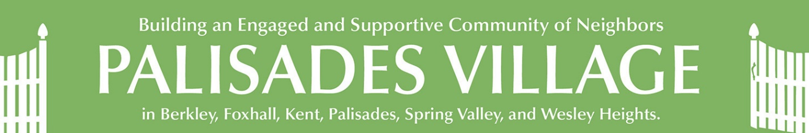
ACROSS THE FENCE
October 17, 2021
This Week at Palisades Village:

Monday, Oct 18 | Tuesday, Oct 19 | Wednesday, Oct 20 | Thursday, Oct 21 | Friday, Oct 22 | Saturday, Oct 23
3:30 p.m.  William Yates Fitness | 9:30 a.m.  Planner Group  3 p.m. Yoga | 8:30 a.m.  Walking Club  5 p.m. Reflections on a Life in News with Gordon Peterson | 3 p.m. Virtual Yoga |  | 9:15 a.m.  Mindful Knitting

This week:

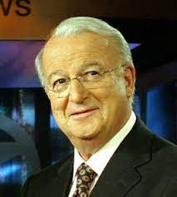 | It seems that Gordon Peterson has been part of the lives of most Washingtonians whether anchoring the local news to moderating Inside Washington. He remains part of our community as a neighbor and is joining Palisades Village to talk about his life on air. Register now for an exciting evening with Gordon Peterson on Wednesday, October 20th at 5 p.m. as he reflects on his life in news.
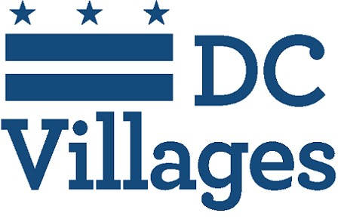 | Please join NNV for their upcoming training on how to become a Medical NoteTaker for all DC village volunteers! Executive director, Stephanie Chong, will be presenting Medical Note-Taking training on Wednesday, October 20th from 10 - 12 p.m. The training is required to volunteer for all medical note-taking requests. A medical note taker is a volunteer who accompanies a member to a medical appointment, listens well, takes notes, and provides notes to the member in a timely fashion. Register now -- space is limited.
Coming up:

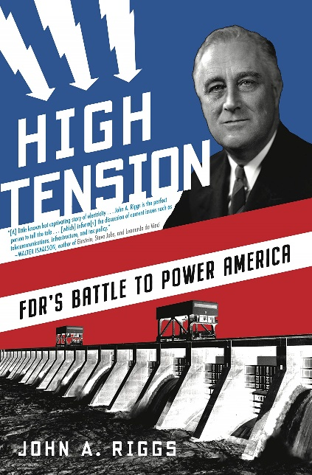 | Palisades Village is proud to present a live Zoom discussion of High Tension: FDR’s Battle to Power America by John A. Riggs on Thursday, October 28th, 7 p.m. In this captivating work of narrative history, Riggs tells the epic story of FDR’s struggle to bring affordable power to the entire nation. The author will be in conversation with another author, PV member and volunteer, Gregory Mize.
The next meeting of the Board of Directors is scheduled for Thursday, November 4 at 5 p.m. on Zoom. The Board meeting is open to the public and visitors may comment and/or ask questions, but only Palisades Village Board members may vote.
Please register for all Palisades Village events that are held in-person or on Zoom. Click on the title in blue to be taken to the registration page and get more information. Click on the registration button and provide your information. You will receive an email with your confirmation soon after. For events on Zoom, this will include the link. There is a complete listing of all events for the next two weeks at the end of the newsletter, or you can go to the website. If you have questions or want to register in person, please call the office at 202-244-3310.

Member Heidi Hertzson Celebrated her 104th Birthday!
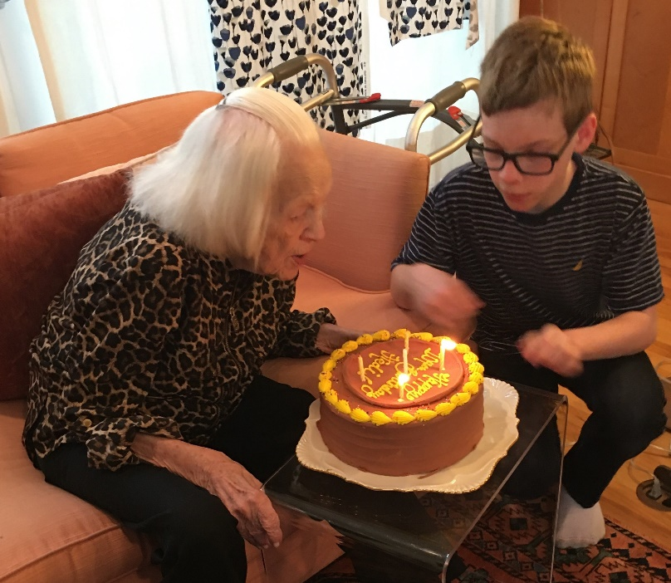

Meet our New Intern:
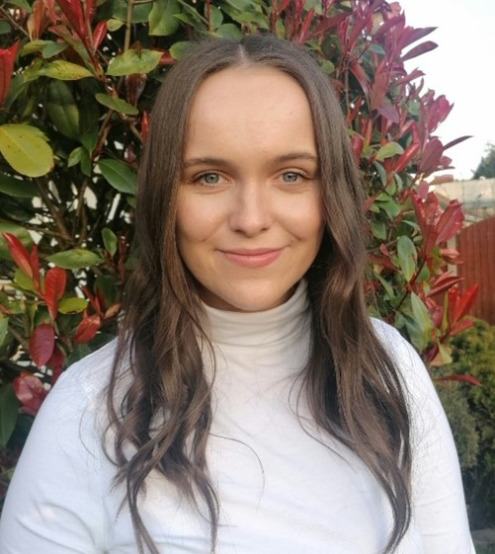 | Hello everyone! I’m Laura, the new art therapy intern at Palisades Village. I’m a 1st year Art Therapy Grad Student at GW. Over the next year, I will be working alongside everyone at Palisades Village to create and run therapeutic art programs. I’m very excited to meet & get to know everyone!  A little about me, I am originally from Ireland and just moved to the DMV area almost two months ago to start grad school. Moving from a small village in rural Ireland to a big area like the DMV has been quite the experience, memorable to say the least! I’m grateful for the opportunity that my grad program has given me to intern with DC Villages and I’m looking forward to getting started soon!
Covid Corner:

Moderna Update: The advisory panel to the Food and Drug Administration voted in favor of emergency authorization of a half-dose booster, at least six months after the second dose. Ruling from the FDA is expected shortly. Those eligible for the extra shot would include people over 65 and other adults considered at high risk — the same groups now eligible for a Pfizer booster.

Members: If you need help getting a Covid vaccination or booster, call the office at 202-244-3310 and we will be glad to help you.

Dial the Area Code:
You need to use the area code when making all calls, including within Washington. This means that all calls in the 202 area code that are currently dialed with seven digits will need to be dialed using the area code + telephone number. If you do not dial the area code + telephone number, your calls will not complete and a recording will instruct you to hang up and dial again, including the area code.
Beginning November 9, 2021, new telephone lines or services may be assigned numbers with the new 771 area code.
If you have speed dial numbers saved on your landline or mobile phone, you will need to reprogram the phone to include the area code, if you haven't already done so. You can still dial just three digits to reach 911 and 311.
Please contact Palisades Village if you need help reprogramming your phone, are not sure if you need to reprogram, or have other questions about this change.

Planning a trip to Fort Totten Transfer Station? You may need to go to Benning Road:
Effective Monday, October 4, 2021, Fort Totten transfer station has new residential drop-off hours. Residents can drop-off Monday through Friday from 10 a.m. until 2 p.m., and Saturday from 7 a.m. until 2 p.m. at 4900 John McCormack Rd NE, Washington, DC 20011.
Household hazardous waste and electronics recycling will no longer be accepted at Fort Totten transfer station. Residents will now be able to drop off their household hazardous waste and electronics recycling every Saturday from 7 a.m. until 2 p.m. at the Benning Road transfer station located at 3200 Benning Road, NE, Washington, DC, 20019.
Document shredding will occur the first Saturday of every month at the Benning Road Transfer Station, beginning November 6, 2021.

DC Village Collaboration
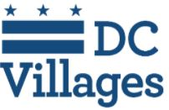
The DC Area Villages work closely together to share resources and access to many events.

For a list of all the events sponsored by Washington Area Villages, please click here. Here are just a few of them. Register by clicking on the link in the title or in the description.

Tuesday, October 19, 11 a.m.
New Frauds and Scams – and Seniors are Often the Intended Targets with Suzanne McGovern, Senior Advisor, Office of Investor Education and Advocacy, U.S. Securities and Exchange Commission

Tuesday, October 26, 1 p.m.
Across the Universe -- The Search for Life with Michael Hamburg

Tuesday, October 26, 2:30 p.m.
How to Get the Most out of your Doctor Visit

Wednesday, October 27, 3 p.m.
“Mythmakers: The Art of Winslow Homer and Frederic Remington” with Dr. Diana Greenwold -- Please contact the GV office at 202-999-8988 or email lynn@georgetown-vllage.org to reserve your spot This Georgetown Village program is free and open to the community.

Community Events:
Go to Around Town DC to find classes in technology, art, dance, advance planning, fitness, improv, and much more.
Sibley Seniors Association (SSA) offers programs and support groups online. Their latest newsletter and calendar are available at https://www.hopkinsmedicine.org/about/community_health/sibley-memorial-hospital/senior-wellness/_docs/sibley-senior-q4-2021-newsletter.pdf

Saturday, October 30, 12 Noon to 6 p.m.
6th Annual Journey to Hope D.C. -- Virtual Conference for Alzheimer’s Family Care Partners. A FREE conference to get updated on Alzheimer’s disease, care, and research. Registration is required • Email Juliet Smith at jsmit470@jhmi.edu or call the Sibley Senior Association office at 202-364-7602
Other Community Events:
Saturday, Oct. 23, 10 a.m. to 2 p.m.
National Prescription Drug Take-Back Day -- Drive up and drop off your unused or expired prescription medications at Sibley Memorial Hospital or Suburban Hospital.

The Palisades History Speakers' series continues through November at the Palisades Hub. Tickets can be found here: https://palisadeshistoryorg.ticketleap.com/

Ongoing Events:

Bereavement Support Groups--Widowed Persons Outreach (WPO) offers both a twice-monthly ongoing support group and twice a year, a six-week structured bereavement group for persons who have been widowed for two years or less. Call 202-537-4942 for more information or go to Calendar | Widowed Persons Outreach (wpodc.org)

Weekly on Fridays, 1 - 2 p.m.
The Art of Looking--By sharing observations, interpretations, questions, and ideas, participants build on their own first impressions and broaden their understanding of a single work of art in each meeting. Each session lasts one hour and is completely interactive. NGA educators will facilitate the conversation to create an environment for shared learning.

Mondays, Wednesdays, and Fridays at 12 p.m.
Smithsonian National Museum of Asian Art’s free 30-minute online meditations-- Led by DC-based meditation teachers, these free sessions are appropriate for all levels of practitioners and include a variety of mindfulness practices. Sessions on Fridays include inspiration from art in the museum collection.

Weekly on Mondays from 2 - 3:15 p.m.
Just Us at the National Gallery of Art -- Provides interactive, discussion-based experiences for people with memory loss and their care partners. For more information go to https://www.nga.gov/calendar/guided-tours/just-us.html. To register, please email access@nga.gov.
Tuesday, Thursday, and Friday from 2:30 - 4 p.m.
Dance for PD -- Bowen McCauley Dance Company provides those with Parkinson's disease and their care partners the opportunity to join us each Tuesday and Friday during the Pandemic. Learn more about the program by clicking here.

COMING UP IN PALISADES VILLAGE
Listed below are details on upcoming events sponsored by Palisades Village. You can now register by clicking on "More Information" and then "Register." You will be prompted to add your name and email address. Please use the email address that the calendar was sent to; it functions as your user ID. If you need to update your email, just let us know. Or you can register by email at eblanton@palisadesvillage.org or call the office at 202-244-3310.

All our events on the village website
This Week at Palisades Village
October 17 — 23, 2021
William Yates Fitness
Mon 10 / 18 / 2021 at 3:30 PM
More Information
Planner Group
Tue 10 / 19 / 2021 at 9:30 AM
More Information
Yoga
Tue 10 / 19 / 2021 at 3:00 PM
Where: Palisades Hub, 5200 Cathedral Ave, NW, Washington, DC 20016
More Information
Walking Club - Georgetown
Wed 10 / 20 / 2021 at 8:30 AM
Where: 4940 Canal Road, NW, Washington, DC 20007
More Information
Reflections on a Life in News with Gordon Peterson
Wed 10 / 20 / 2021 at 5:00 PM
More Information
Virtual Yoga
Thu 10 / 21 / 2021 at 3:00 PM
Where: Via Zoom
More Information
Mindful Knitting
Sat 10 / 23 / 2021 at 9:15 AM
More Information
Next Week at Palisades Village
October 24 — 30, 2021
William Yates Fitness
Mon 10 / 25 / 2021 at 3:30 PM
More Information
Planner Group
Tue 10 / 26 / 2021 at 9:30 AM
More Information
Yoga
Tue 10 / 26 / 2021 at 3:00 PM
Where: Palisades Hub, 5200 Cathedral Ave, NW, Washington, DC 20016
More Information
Storytelling
Tue 10 / 26 / 2021 at 3:00 PM
More Information
Walking Club - Georgetown
Wed 10 / 27 / 2021 at 8:30 AM
Where: 4940 Canal Road, NW, Washington, DC 20007
More Information
Virtual Yoga
Thu 10 / 28 / 2021 at 3:00 PM
Where: Via Zoom
More Information
Conversation with Jack Riggs -- High Tension: FDR's Fight to Power America
Thu 10 / 28 / 2021 at 7:00 PM
More Information
Mindful Knitting
Sat 10 / 30 / 2021 at 9:15 AM
More Information
All our events on the village website
Thank you!
Palisades Village

