ACROSS THE FENCE
March 20, 2022

Spring is here and we are enjoying the vernal view from the office window. The birds and squirrels have been entertaining us with their antics. If you are thinking about exploring fresh starts, our new Living on Purpose series might be for you.

We have some great art and architecture programs coming up on Zoom. We got a sneak peek at Ann Satterthwaite's photo for her talk on old opera houses and it promises to be a fascinating look at history through a very different lens.

More than fifty of you got the chance to meet Anne Ourand, our new Assistant Director, on Pi(e) Day (pictures below). Our next opportunity to get together in person is Wednesday, April 6 at Cafe Vino for Happy Hour. We hope that you will join us. Remember to register early for our gatherings in person so we can plan food accordingly. Full members can always request a ride for these events.

Monday, March 21 | Tuesday, March 22 | Wednesday, March 23 | Thursday, March 24 | Friday, March 25 | Saturday, March 26
1 p.m. Van Gogh Through the Lens of His Art  3:30 p.m. William Yates Fitness In-person or on Zoom | 9:30 a.m. Planner Group  3 p.m. Tales to Talk About  3 p.m. In-person Yoga | Walking Club Cancelled | 2 p.m. Picasso Through the Lens of His Art  3 p.m. Virtual Yoga |  | 9:30 a.m. Mindful Knitting

This Week at Palisades Village:

Van Gogh Through the Lens of his Art
Monday, March 21, 1 p.m.
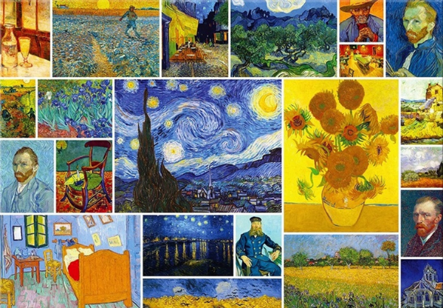
In this month’s art introspection, we will be looking at the fascinating life of Vincent van Gogh. Exploring the connections between van Gogh’s life and art, we will take a dive into the world of van Gogh! Often characterized by his experience of mental illness, van Gogh used his artmaking as a mode of expression and a way to deal with the difficulties he faced in life.
Village members are welcome to create artwork in response to this discussion so are asked to bring along any art materials available to them.
And if you missed the earlier one on Picasso, it will be repeated on Thursday, March 24.

Coming Up:

Thursday, March 31, 1:30-2:30 p.m.
Author Talk with Ann Satterthwaite on Local Glories: Opera Houses on Main Street Where Art and Community Meet
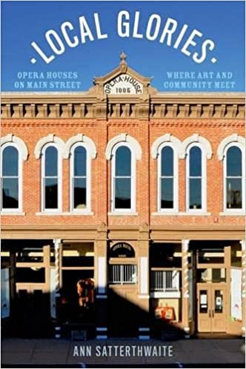
For most people, the term opera house conjures up images of mink-coated dowagers accompanied by tuxedo-clad men in gilded opera houses like the Met in New York and La Scala in Milan. However, the opera house in the United States has a far more varied- and far more interesting- history than the stereotype implies. In Local Glories, Ann Satterthwaite explores the creative, social, and communal roles of the thousands of opera houses that flourished in small towns across the country. By 1900 opera houses were everywhere: on second floors over hardware stores, in grand independent buildings, in the back rooms of New England town halls. and even in the bowels of a Mississippi department store. With the newly expanded rail system, thousands of actors, regional troupes, and minor league magicians, lecturers, and lyceums along with well-known actors like Sarah Bernhardt, lecturers like Mark Twain and Charles Dickens were performing in towns large and small all over the country. This was the golden age of live entertainment.

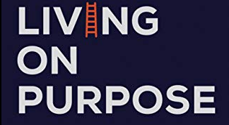 | Living on Purpose  Monday, April 4, 9:30 a.m. - 10:30 a.m.  Kick-off your week with intent! We have expanded on our previous 'Living Life to the Fullest" program with this new bi-weekly series. Discover how to appreciate and embrace each and every day with techniques for living a life you enjoy. Coach Roseanna Stanton will introduce you to simple ways that you can enhance your life, enjoy the present, and move forward with purpose.

Happy Hour at Cafe Vino!
Wednesday, April 6, 5:30 p.m. - 7:30 p.m.
We can't wait to see you -- in person! Palisades Village has ordered some nibbles, and drinks will be available at special prices. This is also a great opportunity to introduce your neighborhood friend to your village friends. Register here. Cafe Vino is at 4885 MacArthur Blvd NW.

Save the Date: Thursday, April 7, 5 p.m. Board Meeting -- The Board meeting is held via Zoom and is open to the public and visitors may comment and/or ask questions, but only Palisades Village Board members may vote. Register here.

Please register for all Palisades Village events that are held in-person or on Zoom. Click on the title in blue to be taken to the registration page and get more information. Click on the registration button and provide your information. You will receive an email with your confirmation soon thereafter. For events on Zoom, this will include the link. There is a complete listing of all events for the next two weeks at the end of the newsletter, or you can go to the website. If you have questions or want to register in person, please call the office at 202-244-3310.

Pi(e) Day was a huge success and we thoroughly enjoyed seeing so many of you on what turned out to be a beautiful day! Thank you to Peggy Banks and Sami Johnson for the huge selection of pies.
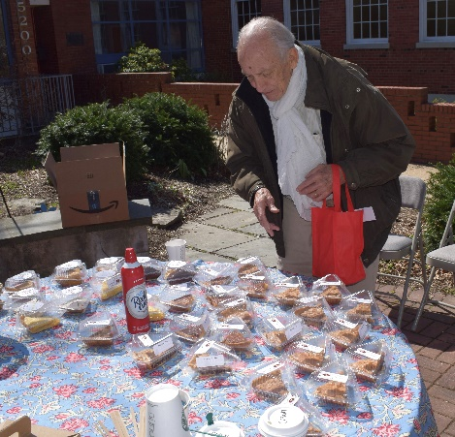 | 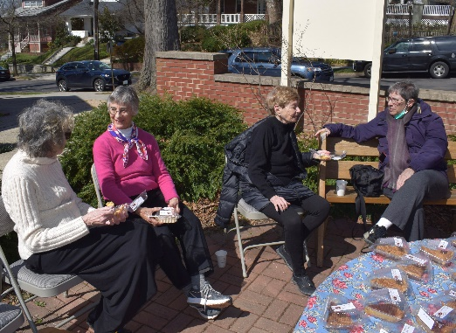 | 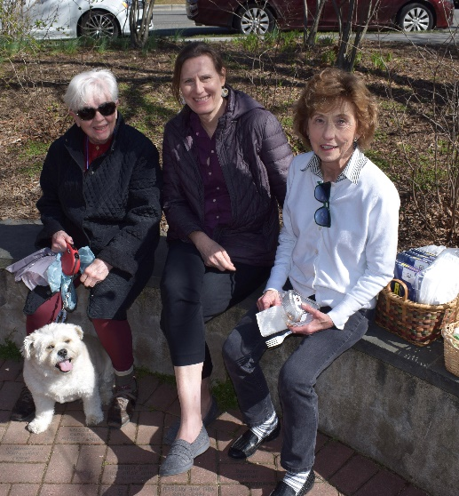



Tech Tip:
Are you having a hard time reading what is on your phone?
If you are an iPhone user, open Settings>Display & Brightness>Text Size. All you have to do is drag the slider to increase the text size to a setting that works best for you. You can also use the VoiceOver feature and have content read out loud to you. This setting, as well as Zoom and Magnifier Tools, can be found under Settings>General>Accessibility.

Interested in being part of planning for the DC Villages Pride Celebration in June?
Contact Sophia Ross at sross@capitolhillvillage.org. She will be setting up the planning meeting. If you would like to represent Palisades Village at upcoming DC Village Safe Space Committee meetings, please let us know.

Palisades Supply Drive for UKRAINE
March 18 - April 30
A 5th grade Palisades resident is coordinating The Palisades Drive for Ukraine. The Palisades Hub (where we are located - 5200 Cathedral Ave NW) is a drop-off location. Current needs include medical supplies (bandages, medicines), personal hygiene items, non-perishable food. Please no liquids, batteries, or clothing. There is a box outside the Cathedral Ave entrance.

Share with us your take on a book, movie, show, album, or exhibit that intrigued you. Send contributions to eblanton@palisadesvillage.org.

Covid Corner:
The Palisades Village Reopening Policy has been updated to include in-person events for masked and fully vaccinated participants.
The new COVID Center for Ward 3 has opened at Chevy Chase Pavilion (5335 Wisconsin Avenue, NW). Individuals have access to vaccinations, boosters, take-home rapid antigen tests, PCR tests, and KN95 masks. Seniors are invited to the front of the line at public testing and vaccination sites.
PCR tests are also available at the Palisades Library and Rec Center. You can pick one up, take the test at home and then drop it off before 8 p.m. You will get the results in 3-5 days.
Palisades Village has some rapid antigen tests and N95 masks. Please contact the office if you need one. You can also pick them up for free at the Cleveland Park Library. Supplies are limited but you can check availability before you go at https://coronavirus.dc.gov/rapidantigen.
Mayor Bowser has updated the city's masking and vaccination requirements. See the details (pages 7 and 8) here.
Can't get out of the house for a vaccination? DC Health will come to you. Call 1-855-363-0333 to request a home visit.
For at-home, on-demand care, and COVID testing, the DC website lists Ready Responders at (202) 602-0814. Ready comes to your home, is open 8 a.m. to 8 p.m., seven days per week, and serves all 8 Wards. Ready is currently offering rapid antigen testing only, with results in 15 minutes. If you require a PCR test, please utilize another testing option.
This week, DC Health also launched Digital Vaccine Record (DVR), a web-based portal that gives District residents secure, easy, and free access to their official COVID-19 vaccination records. To optimize the user experience, DVR will be replacing MyIR for residents to access their COVID-19 vaccination records. MyIR will no longer be available as of March 1, 2022. Click here to learn more or to sign up.
Maintaining your mental health while you wait for test results is important. Certified clinicians are available 24/7 through the DC Department of Behavioral Health’s mental health hotline: 1-888-793-4357.
Members: If you need help getting a vaccination or booster, call the office at 202-244-3310 and we will help you make an appointment and get there.

The DC Area Villages work closely together to share resources and access to many events.

For a list of all the events sponsored by Washington Area Villages, please click here. Here are just a few of them. Register by clicking on the link in the title or in the description.

Thursday, March 24, 11 a.m.
Childless Older Americans -- More than 15 million adults, or nearly one in six Americans aged 55 and older, are childless, and the levels of childlessness among adults are expected to increase. Using data from the U.S. Census Bureau’s 2018 Survey of Income and Program Participation (SIPP), Dr. Tayelor Valerio will provide an overview of the childless older American population and compare their demographic, economic, health, and household characteristics to those of biological parents of the same age group. Registration required.

Thursday, March 31, 2 p.m.
Warhol's Women -- Some people may have heard about Andy Warhol's close, lifelong relationship with his mother, but that relationship was about more than just love and blood. Blake Gopnik, author of Warhol, the first comprehensive biography of the Pop artist, will tell us about new research shows that Julia Warhol played an important role in her son's artmaking, as did several female colleagues who influenced him. Registration required.

Community Events:
Go to Around Town DC to find classes in technology, art, dance, advance planning, fitness, improv, and much more. Around Town DC’s program at St. Alban’s Nourse Hall welcomes DC residents 60 and older. Join the (masked and vaccinated) group for coffee at 10-11 a.m., a variety of fitness programs from 11-12 noon, a nutritious lunch from noon-12:45 p.m., and arts programs in the afternoon. Bring your vaccine card and ID and try out any or all of it! See what else this wonderful community has to offer by visiting https://www.aroundtowndc.org/. Create an account and take a look at the “In-Person Events” under “Upcoming Events” or email program manager, Frances Bucien Fbucien@iona.org. You are also welcome to call her at 202.656.5488. Sign up for the Newsletter while you are there!
March PT Shorts -- Physical Therapy in only 15 minutes
March 22 & 29 – GWU/Physical Therapy Department graduate students will design and conduct 5 special PT SHORT sessions to keep you STRONG, ACTIVE, and SAFE. Register for as many as you want! All sessions will be on zoom and recorded so that you can make them part of your weekly fitness routine. See details following. If you have any questions, please contact Nadia Taran at nadiataran@mindspring.com.
- Energizing Full-Body Morning Stretch, Tuesday, March 22, 12:30-12:45 pm – Is your get-up-and-go still stuck in bed? Join Kate, Allison, Emma, and Brianna for a head-to-toe easy routine that will leave you ready to face the day. Register here.
- Benefits of Maintaining Muscle Mass, Tuesday, March 22, 1:00-1:15 pm –Remember the saying “use it or lose it?” In just 15 minutes, Rachael, Kate, Hannah, and Kristina will show you ways you can maintain your muscle mass and what effect it can have on your daily life! Register here.
- Keeping Arthritic Joints Healthy and Happy, Tuesday, March 29, 12:30-12:45 pm – Are you sitting out some of your favorite pastimes? Join Renee, Roberto, Brian, and Chloe for a brief overview of arthritis and learn some do’s and don’ts. The team will show you exercises you can do at home to improve your range of motion safely. Register here.
- Exercises/Stretches after Long Sedentary Periods, Tuesday, March 29, 1:00-1:15 pm – They say that “sitting” is the new smoking. If you can’t break yourself from the habit of sitting for long periods at the computer, or watching TV, then this session is for you. Join Devni, Caro, Tesia, and Caroline for a short but much-needed stretch break. Warning: the exercises may be habit forming. Register here.
Technology Tuesdays, 11 a.m.
Refresh your skills on a variety of topics with B Milenkovic from the Labs at MLK library. Sign up for the programs and you will receive a Zoom link for each session. Ignore the invite if the topic isn’t of interest to you. The March 22nd topic: Intro to Google Drive.

Wednesdays, 10 a.m.
Strength, Balance, and Core in person at the Palisades Rec Center -- Emma Swain will be joining us to help us with strength, balance, and core. This class combines dynamic and functional strength and balance exercises using seated and standing exercises.

Wednesdays, 1:30 p.m.
Yoga at Palisades Library -- Specifically geared towards older adults. Registration is required here. The poses are all standing or seated, so no mats are required. Please note, masks are still required at the library.

Sibley Seniors Association (SSA) offers programs and support groups online.

Other Community Events:
March 16 - April 10
Theater J and Folger Theatre Present Gotthold Lessing’s Classic Nathan the Wise
For info and tickets, call the Box Office at 202-777-3210 or click here.
Hurry! The show is almost sold out. VILLAGERS ENJOY A 15% DISCOUNT: code VILLAGES
Saturday, March 26, 8 p.m.
"WHFS Night" and Rocklands BBQ @ The Hub Cap Centre - The HalFSmokes cover favorites from WHFS playlists of the late ‘70s to the early 90s. For more information click here.

Sunday, March 27, 5 p.m.
Jazz Club @ The Palisades Hub Social Hall featuring Tim Whalen & Zack Pride. For more information click here.

Saturday, April 2, 10 a.m.
The Palisades Community Association Annual Easter Egg Hunt & Potluck Breakfast -- Are the grandchildren visiting? If so, head on over to this annual event. Bag decorating at 10 a.m., followed by the egg hunt at 10:30 sharp and lawn games including an egg toss after that. With or without children or grandchildren, this is sure to be a cute event and all are invited!

Ongoing Events:

Bereavement Support Groups--Widowed Persons Outreach (WPO) offers both a twice-monthly ongoing support group and twice a year, a six-week structured bereavement group for persons who have been widowed for two years or less. Call 202-537-4942 for more information or go to Calendar | Widowed Persons Outreach (wpodc.org) | Bi-Weekly on Fridays, 1 - 2 p.m.  The Art of Looking--By sharing observations, interpretations, questions, and ideas, participants build on their own first impressions and broaden their understanding of a single work of art in each meeting. Each session lasts one hour and is completely interactive. NGA educators will facilitate the conversation to create an environment for shared learning.
Mondays, Wednesdays, and Fridays at noon.  Smithsonian National Museum of Asian Art’s free 30-minute online meditations-- Led by DC-based meditation teachers, these free sessions are appropriate for all levels of practitioners and include a variety of mindfulness practices. Sessions on Fridays include inspiration from art in the museum collection. | Weekly on Mondays from 2 - 3:15 p.m.  Just Us at the National Gallery of Art -- Provides interactive, discussion-based experiences for people with memory loss and their care partners. For more information go to https://www.nga.gov/calendar/guided-tours/just-us.html. To register, please email access@nga.gov.
Weekly on Wednesdays at 2:30 p.m.
Dance for PD -- Now in person at the Kennedy Center's REACH building. Join local Dance for Parkinson's Disease certified instructor Lucy Bowen McCauley for a free workshop where participants are empowered to explore movement and music in ways that are refreshing, enjoyable, stimulating, and creative. Learn more about the program by clicking here.

COMING UP IN PALISADES VILLAGE
Listed below are details on upcoming events sponsored by Palisades Village. You can now register by clicking on "More Information" and then "Register." You will be prompted to add your name and email address. Please use the email address that the calendar was sent to; it functions as your user ID. If you need to update your email, just let us know. Or you can register by email at aourand@palisadesvillage.org or call the office at 202-244-3310.
ALL OUR EVENTS ON THE VILLAGE WEBSITE
This Week at Palisades Village
March 20 — 26, 2022
Van Gogh Through the Lens of his Art
Mon 03 / 21 / 2022 at 1:00 PM
More Information
William Yates Fitness
Mon 03 / 21 / 2022 at 3:30 PM
More Information
Planner Group
Tue 03 / 22 / 2022 at 9:30 AM
More Information
Yoga
Tue 03 / 22 / 2022 at 3:00 PM
Where: Palisades Hub, 5200 Cathedral Ave NW, Washington, DC 20016
More Information
Tales to Talk About
Tue 03 / 22 / 2022 at 3:00 PM
More Information
Repeat -- Picasso Through the Lens of His Art
Thu 03 / 24 / 2022 at 2:00 PM
More Information
Virtual Yoga
Thu 03 / 24 / 2022 at 3:00 PM
Where: Via Zoom
More Information
Mindful Knitting
Sat 03 / 26 / 2022 at 9:30 AM
More Information
Next Week at Palisades Village
March 27 — April 2, 2022
William Yates Fitness
Mon 03 / 28 / 2022 at 3:30 PM
More Information
Planner Group
Tue 03 / 29 / 2022 at 9:30 AM
More Information
Yoga
Tue 03 / 29 / 2022 at 3:00 PM
Where: Palisades Hub, 5200 Cathedral Ave NW, Washington, DC 20016
More Information
Walking Club - Georgetown
Wed 03 / 30 / 2022 at 8:30 AM
Where: 4940 Canal Road, NW, Washington, DC 20007
More Information
Author Talk with Ann Satterthwaite on Local Glories: Opera Houses on Main Street Where Art and Community Meet
Thu 03 / 31 / 2022 at 1:30 PM
More Information
Virtual Yoga
Thu 03 / 31 / 2022 at 3:00 PM
Where: Via Zoom
More Information
Mindful Knitting
Sat 04 / 02 / 2022 at 9:30 AM
More Information
ALL OUR EVENTS ON THE VILLAGE WEBSITE
Thank you!
Palisades Village



